REACT HANDS ON 13

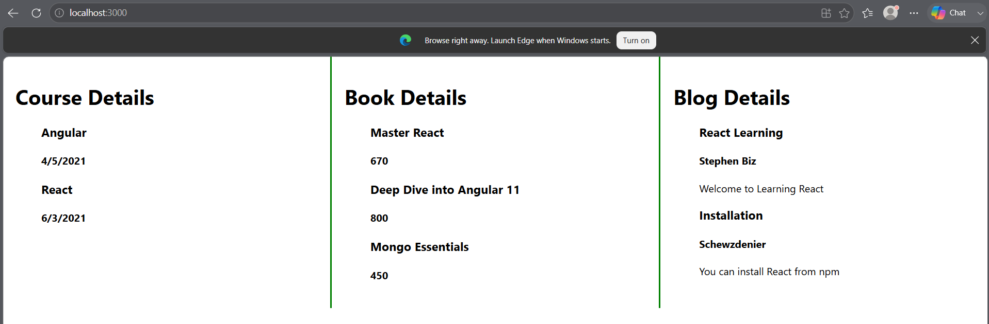

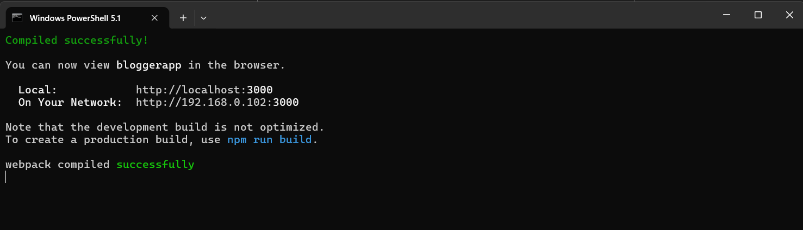

APP.CSS
.container {
display: flex;
}

.column {
flex: 1;
padding: 20px;
border-right: 3px solid green;
}

.column:last-child {
border-right: none;
}
APP.JS
import './App.css';

function App() {

const books = [
{
id: 101,
bname: 'Master React',
price: 670
},
{
id: 102,
bname: 'Deep Dive into Angular 11',
price: 800
},
{
id: 103,
bname: 'Mongo Essentials',
price: 450
}
];

const blogs = [
{
id: 1,
title: 'React Learning',
author: 'Stephen Biz',
content: 'Welcome to Learning React'
},
{
id: 2,
title: 'Installation',
author: 'Schewzdenier',
content: 'You can install React from npm'
}
];

const courses = [
{
id: 1,
cname: 'Angular',
date: '4/5/2021'
},
{
id: 2,
cname: 'React',
date: '6/3/2021'
}
];

const bookdet = (
<ul>
{
books.map((book) =>
<div key={book.id}>
<h3>{book.bname}</h3>
<h4>{book.price}</h4>
</div>
)
}
</ul>
);

const content = (
<ul>
{
blogs.map((blog) =>
<div key={blog.id}>
<h3>{blog.title}</h3>
<h4>{blog.author}</h4>
<p>{blog.content}</p>
</div>
)
}
</ul>
);

const coursedet = (
<ul>
{
courses.map((course) =>
<div key={course.id}>
<h3>{course.cname}</h3>
<h4>{course.date}</h4>
</div>
)
}
</ul>
);

return (
<div>

<div className="container">

<div className="column">
<h1>Course Details</h1>
{coursedet}
</div>

<div className="column">
<h1>Book Details</h1>
{bookdet}
</div>

<div className="column">
<h1>Blog Details</h1>
{content}
</div>

</div>

</div>
);
}

export default App;

